Why sigmoid in logistic regression?
The question I thought is why do we even choose sigmoid function in logistic regression. If we simply need value in range [0,1] we could have chosen some other function giving this range.

Log Odds
First let’s understand what are log-odds. And to understand log-odds, first let’s look into odds.
So ‘odd’ is basically ratio of probability of occurance and non-occurance.
odds = $\frac{P(x)}{1-P(x)}$
e.g:
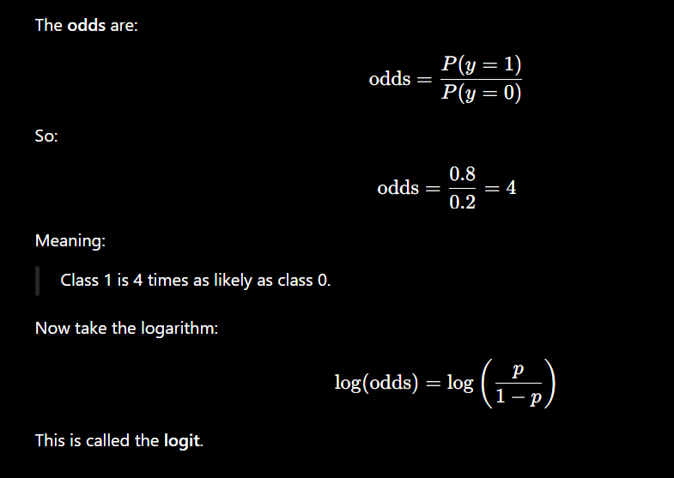
So, odds tells us how much more probable a class is than other.
Now, let’s come to the log-odds.
When we take logarithm of odds, it then becomes a score in range (-∞ to +∞). Now this score is another representation of odds-score in expended range.
Logistic regression assumes that ‘z’ is basically the log-odds score (means it shows occurance vs non-occurance of a class).

Log-odds to Sigmoid
We saw above that logistic regression assumes:
z = log ($\frac{P(x)}{1-P(x)}$)
$e^{z}$ = $\frac{P(x)}{1-P(x)}$
$e^{z}$ $(1-P\left(x\right))$ = P(x)
$e^{z}$ – P(x) $e^{z}$ = P(x)
P(x) + P(x) $e^{z}$ = $e^{z}$
P(x) (1 + $e^{z}$) = $e^{z}$
P(x) = $\frac{e^{z} }{1+ e^{z} }$ = $\frac{1}{1+ e^{-z} }$
Therefore, taking sigmoid models raw scores as log-odds.

